

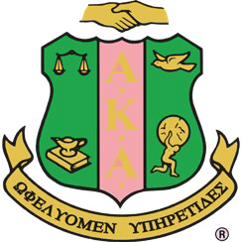Alpha Kappa Alpha Sorority, Incorporated®

**Youth Leadership Institute (YLI)**

*AKAdettes*

Committee Meeting Agenda

Wednesday, May 10, 2023@ 7:30 pm -8:30 pm via Zoom

* Welcome
* Recap of EOY activity
* Recap of 2022-23 / Plans for upcoming year 2023-24
  + Start date
  + Date to send out applications
  + Schools to send applications to
  + Application deadline
  + Number of AKAdettes accepted
  + Mentors/mentees
  + New logo/ shirts
  + Curriculum and ideas for monthly events Sept-Dec
* Remaining Budget for 2023-2024:
* Closing remarks/discussion